**Rethink Activity:**

**Supporting people severely affected by mental illness and carers to be more active**

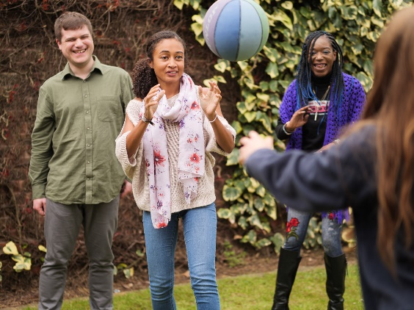Rethink Mental Illness has been awarded funding from Sport England to support people severely affected by mental illness to be more active and break down barriers to participation. Working with existing networks of mental health services and peer support groups, as well as establishing new groups, we are supporting them to embed physical activity into their current offer using a toolkit which has been co-produced with people with lived experience of mental illness. The aim is to support people with mental health issues and carers to achieve a minimum of 30 minutes per week of physical activity.

The emphasis is on informal, recreational activities rather than structured coached activity. We want to create sustainable opportunities for people experiencing mental health issues to be active. All groups, services and organisations who are part of the project will receive a package of information, resources and support;

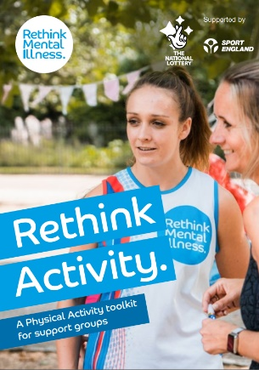- **Toolkit** – this has been developed in partnership with people with lived experience of mental illness. It is designed for organisations that work with people with mental health issues and want to expand their offer by embedding physical activity. Toolkit includes a range of information;

> What is physical activity and what are the benefits?

> Barriers and ways to overcome them

> Member journey (behaviour change)

> Top tips

> Step by step guide

> Activity ideas

> Useful contacts

- **Resources** – we provide all necessary templates for the activity, including session register, Physical Activity Readiness Questionnaire, risk assessment, and letter/email template for local organisations (Active Partnerships, local authorities, schools and colleges, sports clubs, etc).

- **Information and guidance** – whether that’s sourcing a venue or finding an instructor, we can link organisations to local partners, including Active Partnerships. We can also advise on what activities they could try and share good practice.

- **Funding** – there is a limited amount of funding available to support with the development of activities. The amount is based on the individual needs of each group but can cover equipment, venue hire, instructors and training. Where funding is provided, a sustainability plan is embedded from the beginning to ensure activities can continue in the long term without the need for external funding.

**Who can we support through the project?**

- Existing peer support groups which focus on mental health recovery

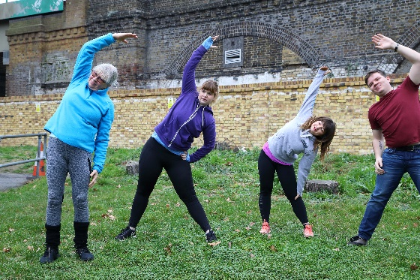- Groups and organisations for carers of people with mental health issues

- Services which support people’s mental health

- Community groups or sports clubs who have an interest in mental health

- Individuals who want to set up a new group or activity for people with mental health issues

**How can you get involved?**

|  |  |
| --- | --- |
| Existing peer support groups and services | * Talk to us about your group/service and your requirements * If you’re not sure how to start physical activity or even if you want to start, get in touch and we can talk it through * Make use of the toolkit specifically designed to help |
| Local/regional organisation  (NHS trust, Active Partnership, local authority, charity, etc.) | * Promote activities being delivered in your area * Raise awareness of project to local groups and organisations who might be interested in being involved and put them in touch with us * Support with locating suitable venues, instructors, equipment, training opportunities |
| Individual (interest in physical activity and mental health) | * If you’re keen to know more about physical activity and mental health get in touch and we can talk it over * You could set up your own peer support group, with our help, and start offering physical activity opportunities to people in your local area * We can help with promotion, set up, training, plus lots more |

**What can you do now?**

Contact Mel Islin at [mel.islin@rethink.org](mailto:mel.islin@rethink.org) to find out more about the project, share what you’re doing around mental wellbeing, and discuss ways of working together.

**What our groups and services say about being part of the project**

*“It’s very uplifting…these physical activities give me energy and positivity and I feel better in myself”*

Group member

*“I always feel when I come in and when I leave here, I feel a much better person”*

Group member

*“Some of them are even – not only doing the exercises once a week at the group, but also they’re doing them when they’re at home as well”*

Group lead

*“Being involved in it, it’s helped my confidence”*

Group member

*“The social side here is so important, it’s a very, very important side of it”*

Group member

*“It gives me a sense of achievement by leading the group”*

Group lead